**Problem 1**

Find the smallest prime that is the fifth term of an increasing arithmetic sequence, all four preceding terms also being prime.

[Solution](https://artofproblemsolving.com/wiki/index.php?title=1999_AIME_Problems/Problem_1)

## Solution

Obviously, all of the terms must be [odd](https://artofproblemsolving.com/wiki/index.php?title=Odd). The common difference between the terms cannot be $2$ or $4$, since otherwise there would be a number in the sequence that is divisible by $3$. However, if the common difference is $6$, we find that $5,11,17,23$, and $29$ form an [arithmetic sequence](https://artofproblemsolving.com/wiki/index.php?title=Arithmetic_sequence). Thus, the answer is $029$.

## Alternate Solution

If we let the arithmetic sequence to be $p, p+a, p+2a, p+3a$, and $p+4a$, where $p$ is a prime number and $a$ is a positive integer, we can see that $p$ cannot be multiple of $2$ or $3$ or $4$. Smallest such prime number is $5$, and from a quick observation we can see that when $a$ is $6$, the terms of the sequence are all prime numbers. The sequence becomes $5, 11, 17, 23, 29$, so the answer is $029$.

**------------------------------------------------------------------------------------------------**

**Problem 2**

Consider the parallelogram with vertices $(10,45),$ $(10,114),$ $(28,153),$ and $(28,84).$ A line through the origin cuts this figure into two congruent polygons. The slope of the line is $m/n,$ where $m_{}$ and $n_{}$ are relatively prime positive integers. Find $m+n.$

[Solution](https://artofproblemsolving.com/wiki/index.php?title=1999_AIME_Problems/Problem_2)

## Solution

### Solution 1

Let the first point on the line $x=10$ be $(10,45+a)$ where a is the height above $(10,45)$. Let the second point on the line $x=28$ be $(28, 153-a)$. For two given points, the line will pass the origin iff the coordinates are [proportional](https://artofproblemsolving.com/wiki/index.php?title=Proportion) (such that 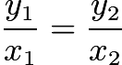). Then, we can write that 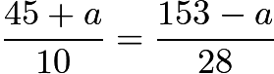. Solving for $a$ yields that $1530 - 10a = 1260 + 28a$, so 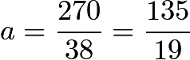. The slope of the line (since it passes through the origin) is 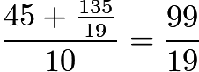, and the solution is $m + n = \boxed{118}$.

### Solution 2

You can clearly see that a line that cuts a parallelogram into two congruent pieces must go through the center of the parallelogram. Taking the midpoint of $(10,45)$, and $(28,153)$ gives $(19,99)$, which is the center of the parallelogram. Thus the slope of the line must be $\frac{99}{19}$, and the solution is $\boxed{118}$.

**Problem 3**

Find the sum of all positive integers $n$ for which $n^2-19n+99$ is a perfect square.

[Solution](https://artofproblemsolving.com/wiki/index.php?title=1999_AIME_Problems/Problem_3)

## Solution 1

If $n^2-19n+99=x^2$ for some positive integer $x$, then rearranging we get $n^2-19n+99-x^2=0$. Now from the quadratic formula,

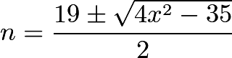

Because $n$ is an integer, this means $4x^2-35=q^2$ for some nonnegative integer $q$. Rearranging gives $(2x+q)(2x-q)=35$. Thus $(2x+q, 2x-q)=(35, 1)$ or $(7,5)$, giving $x=3$ or $9$. This gives $n=1, 9, 10,$ or $18$, and the sum is $1+9+10+18=\boxed{38}$.

## Solution 2

Suppose there is some $k$ such that $x^2 - 19x + 99 = k^2$. Completing the square, we have that $(x - 19/2)^2 + 99 - (19/2)^2 = k^2$, that is, $(x - 19/2)^2 + 35/4 = k^2$. Multiplying both sides by 4 and rearranging, we see that $(2k)^2 - (2x - 19)^2 = 35$. Thus, $(2k - 2x + 19)(2k + 2x - 19) = 35$. We then proceed as we did in the previous solution.

## Solution 3

When $n \geq 12$, we have\[(n-10)^2 < n^2 -19n + 99 < (n-8)^2.\]

So if $n \geq 12$ and $n^2 -19n + 99$ is a perfect square, then\[n^2 -19n + 99 = (n-9)^2\]

or $n = 18$.

For $1 \leq n < 12$, it is easy to check that $n^2 -19n + 99$ is a perfect square when $n = 1, 9$ and $10$ ( using the identity $n^2 -19n + 99 = (n-10)^2 + n - 1.)$

We conclude that the answer is $1 + 9 + 10 + 18 = \boxed{38}.$

**Problem 4**

The two squares shown share the same center $O_{}$ and have sides of length 1. The length of $\overline{AB}$ is $43/99$ and the area of octagon $ABCDEFGH$ is $m/n,$ where $m_{}$ and $n_{}$ are relatively prime positive integers. Find $m+n.$

[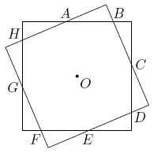](https://artofproblemsolving.com/wiki/index.php?title=File:AIME_1999_Problem_4.png)

[Solution](https://artofproblemsolving.com/wiki/index.php?title=1999_AIME_Problems/Problem_4)

### Solution 1

Define the two possible [distances](https://artofproblemsolving.com/wiki/index.php?title=Distance) from one of the labeled points and the [corners](https://artofproblemsolving.com/wiki/index.php?title=Vertex) of the square upon which the point lies as $x$ and $y$. The area of the [octagon](https://artofproblemsolving.com/wiki/index.php?title=Octagon) (by [subtraction](https://artofproblemsolving.com/wiki/index.php?title=Subtraction) of areas) is 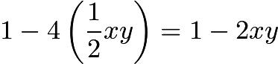.

By the [Pythagorean theorem](https://artofproblemsolving.com/wiki/index.php?title=Pythagorean_theorem),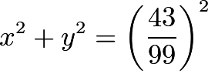

Also,

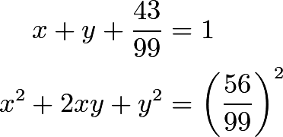

Substituting,

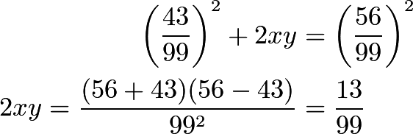

Thus, the area of the octagon is 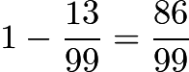, so $m + n = \boxed{185}$.

### Solution 2

Triangles $AOB$, $BOC$, $COD$, etc. are congruent, and each area is 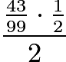. Since the area of a triangle is $bh/2$, the area of all $8$ of them is $\frac{86}{99}$and the answer is $\boxed{185}$.

**Problem 5**

For any positive integer $x_{}$, let $S(x)$ be the sum of the digits of $x_{}$, and let $T(x)$ be $|S(x+2)-S(x)|.$ For example, $T(199)=|S(201)-S(199)|=|3-19|=16.$ How many values of $T(x)$ do not exceed 1999?

[Solution](https://artofproblemsolving.com/wiki/index.php?title=1999_AIME_Problems/Problem_5)

## Solution

For most values of $x$, $T(x)$ will equal $2$. For those that don't, the difference must be bumping the number up a ten, a hundred, etc. If we take $T(a999)$ as an example,\[|(a + 1) + 0 + 0 + 1 - (a + 9 + 9 + 9)| = |2 - 9(3)|\]And in general, the values of $T(x)$ will then be in the form of $|2 - 9n| = 9n - 2$. From $7$ to $1999$, there are 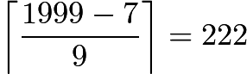 solutions; including $2$ and there are a total of $\boxed{223}$ solutions.

**Problem 6**

A transformation of the first quadrant of the coordinate plane maps each point $(x,y)$ to the point $(\sqrt{x},\sqrt{y}).$ The vertices of quadrilateral $ABCD$are $A=(900,300), B=(1800,600), C=(600,1800),$ and $D=(300,900).$ Let $k_{}$ be the area of the region enclosed by the image of quadrilateral $ABCD.$ Find the greatest integer that does not exceed $k_{}.$

[Solution](https://artofproblemsolving.com/wiki/index.php?title=1999_AIME_Problems/Problem_6)

## Solution

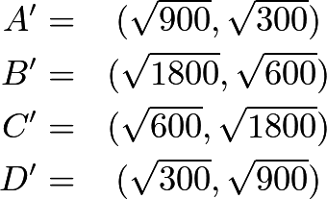

First we see that lines passing through $AB$ and $CD$ have [equations](https://artofproblemsolving.com/wiki/index.php?title=Equation) 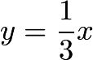 and $y = 3x$, respectively. Looking at the points above, we see the equations for $A'B'$ and $C'D'$ are 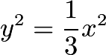 and $y^2 = 3x^2$, or, after manipulation 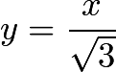 and $y = \sqrt {3}x$, respectively, which are still linear functions. Basically the square of the image points gives back the original points and we could plug them back into the original equation to get the equation of the image lines.

Now take a look at $BC$ and $AD$, which have the equations $y = - x + 2400$ and $y = - x + 1200$. The image equations hence are $x^2 + y^2 = 2400$ and $x^2 + y^2 = 1200$, respectively, which are the equations for [circles](https://artofproblemsolving.com/wiki/index.php?title=Circle).

[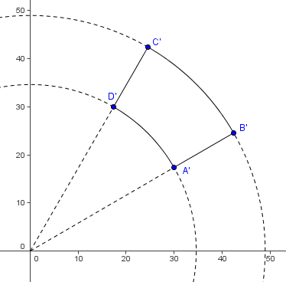](https://artofproblemsolving.com/wiki/index.php?title=File:1999_AIME-6.png)

To find the area between the circles (actually, parts of the circles), we need to figure out the [angle](https://artofproblemsolving.com/wiki/index.php?title=Angle) of the [arc](https://artofproblemsolving.com/wiki/index.php?title=Arc). This could be done by 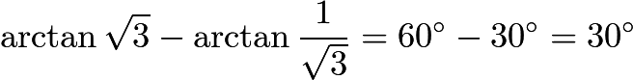. So the requested areas are the area of the enclosed part of the smaller circle subtracted from the area enclosed by the part of the larger circle = 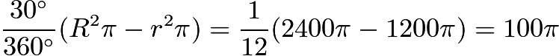. Hence the answer is $\boxed{314}$.

**Problem 7**

There is a set of 1000 switches, each of which has four positions, called $A, B, C$, and $D$. When the position of any switch changes, it is only from $A$ to $B$, from $B$ to $C$, from $C$ to $D$, or from $D$ to $A$. Initially each switch is in position $A$. The switches are labeled with the 1000 different integers $(2^{x})(3^{y})(5^{z})$, where $x, y$, and $z$ take on the values $0, 1, \ldots, 9$. At step i of a 1000-step process, the $i$-th switch is advanced one step, and so are all the other switches whose labels divide the label on the $i$-th switch. After step 1000 has been completed, how many switches will be in position $A$?

[Solution](https://artofproblemsolving.com/wiki/index.php?title=1999_AIME_Problems/Problem_7)

## Solution

For each $i$th switch (designated by $x_{i},y_{i},z_{i}$), it advances *itself* only one time at the $i$th step; thereafter, only a switch with larger $x_{j},y_{j},z_{j}$ values will advance the $i$th switch by one step provided $d_{i}= 2^{x_{i}}3^{y_{i}}5^{z_{i}}$ divides $d_{j}= 2^{x_{j}}3^{y_{j}}5^{z_{j}}$. Let $N = 2^{9}3^{9}5^{9}$ be the max switch label. To find the divisor multiples in the range of $d_{i}$ to $N$, we consider the exponents of the number 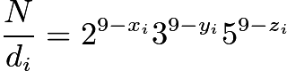. In general, the divisor-count of $\frac{N}{d}$must be a multiple of 4 to ensure that a switch is in position A:

$4n = [(9-x)+1] [(9-y)+1] [(9-z)+1] = (10-x)(10-y)(10-z)$, where $0 \le x,y,z \le 9.$

We consider the cases where the 3 factors above do not contribute multiples of 4.

* Case of no 2's:

The switches must be $(\mathrm{odd})(\mathrm{odd})(\mathrm{odd})$. There are $5$ [odd integers](https://artofproblemsolving.com/wiki/index.php?title=Odd_integer) in $0$ to $9$, so we have $5 \times 5 \times 5 = 125$ ways.

* Case of a single 2:

The switches must be one of $(2\cdot \mathrm{odd})(\mathrm{odd})(\mathrm{odd})$ or $(\mathrm{odd})(2 \cdot \mathrm{odd})(\mathrm{odd})$ or $(\mathrm{odd})(\mathrm{odd})(2 \cdot \mathrm{odd})$.

Since $0 \le x,y,z \le 9,$ the terms $2\cdot 1, 2 \cdot 3,$ and $2 \cdot 5$ are three valid choices for the $(2 \cdot odd)$ factor above.

We have 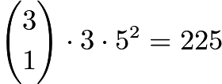 ways.

The number of switches in position A is $1000-125-225 = \boxed{650}$.

**Problem 8**

Let $\mathcal{T}$ be the set of ordered triples $(x,y,z)$ of nonnegative real numbers that lie in the plane $x+y+z=1.$ Let us say that $(x,y,z)$ supports $(a,b,c)$ when exactly two of the following are true: $x\ge a, y\ge b, z\ge c.$ Let $\mathcal{S}$ consist of those triples in $\mathcal{T}$ that support 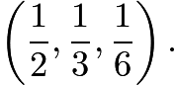 The area of $\mathcal{S}$ divided by the area of $\mathcal{T}$ is $m/n,$ where $m_{}$ and $n_{}$ are relatively prime positive integers, find $m+n.$

[Solution](https://artofproblemsolving.com/wiki/index.php?title=1999_AIME_Problems/Problem_8)

**Problem 9**

A function $f$ is defined on the complex numbers by $f(z)=(a+bi)z,$ where $a_{}$ and $b_{}$ are positive numbers. This function has the property that the image of each point in the complex plane is equidistant from that point and the origin. Given that $|a+bi|=8$ and that $b^2=m/n,$ where $m_{}$ and $n_{}$are relatively prime positive integers. Find $m+n.$

[Solution](https://artofproblemsolving.com/wiki/index.php?title=1999_AIME_Problems/Problem_9)

**------------------------------------------------------------------------------------------------**

**Problem 10**

Ten points in the plane are given, with no three collinear. Four distinct segments joining pairs of these points are chosen at random, all such segments being equally likely. The probability that some three of the segments form a triangle whose vertices are among the ten given points is $m/n,$ where $m_{}$ and $n_{}$ are relatively prime positive integers. Find $m+n.$

[Solution](https://artofproblemsolving.com/wiki/index.php?title=1999_AIME_Problems/Problem_10)

## Solution

First, let us find the number of triangles that can be formed from the 10 points. Since none of the points are collinear, it is possible to pick 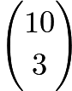sets of 3 points which form triangles. However, a fourth distinct segment must also be picked. Since the triangle accounts for 3 segments, there are $45 - 3 = 42$ segments remaining.

The total number of ways of picking four distinct segments is 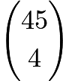. Thus, the requested probability is 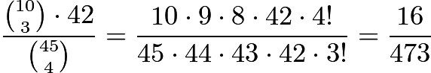. The solution is $m + n = 489$.

**Problem 11**

Given that 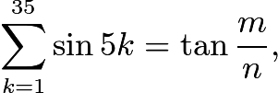 where angles are measured in degrees, and $m_{}$ and $n_{}$ are relatively prime positive integers that satisfy 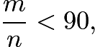find $m+n.$

[Solution](https://artofproblemsolving.com/wiki/index.php?title=1999_AIME_Problems/Problem_11)

**Problem 12**

The inscribed circle of triangle $ABC$ is tangent to $\overline{AB}$ at $P_{},$ and its radius is 21. Given that $AP=23$ and $PB=27,$ find the perimeter of the triangle.

[Solution](https://artofproblemsolving.com/wiki/index.php?title=1999_AIME_Problems/Problem_12)

## Solution

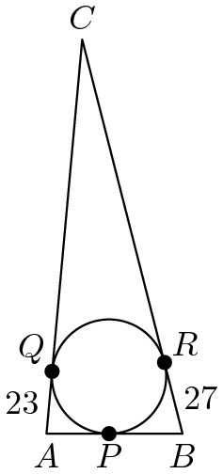

### Solution 1

Let $Q$ be the tangency point on $\overline{AC}$, and $R$ on $\overline{BC}$. By the [Two Tangent Theorem](https://artofproblemsolving.com/wiki/index.php?title=Two_Tangent_Theorem), $AP = AQ = 23$, $BP = BR = 27$, and $CQ = CR = x$. Using $rs = A$, where 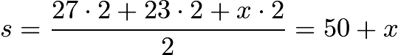, we get $(21)(50 + x) = A$. By [Heron's formula](https://artofproblemsolving.com/wiki/index.php?title=Heron%27s_formula), . Equating and squaring both sides,

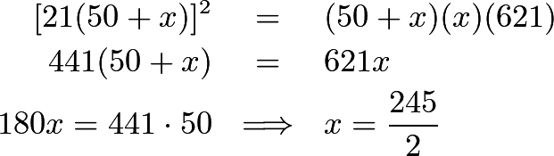

We want the perimeter, which is 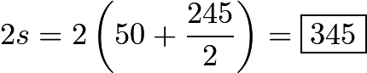.

### Solution 2

Let the incenter be denoted $I$. It is commonly known that the incenter is the intersection of the angle bisectors of a triangle. So let $\angle ABI = \angle CBI = \alpha, \angle BAI = \angle CAI = \beta,$ and $\angle BCI = \angle ACI = \gamma.$

We have that

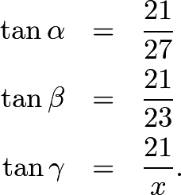

So naturally we look at $\tan \gamma.$ But since 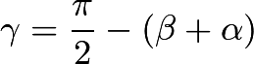 we have

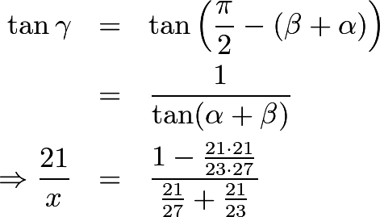

Doing the algebra, we get 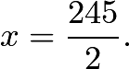

The perimeter is therefore 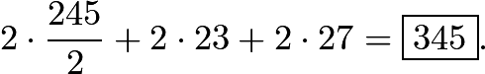

**Problem 13**

Forty teams play a tournament in which every team plays every other($39$ different opponents) team exactly once. No ties occur, and each team has a $50 \%$ chance of winning any game it plays. The probability that no two teams win the same number of games is $m/n,$ where $m_{}$ and $n_{}$ are relatively prime positive integers. Find $\log_2 n.$

[Solution](https://artofproblemsolving.com/wiki/index.php?title=1999_AIME_Problems/Problem_13)

**Problem 14**

Point $P_{}$ is located inside triangle $ABC$ so that angles $PAB, PBC,$ and $PCA$ are all congruent. The sides of the triangle have lengths $AB=13, BC=14,$ and $CA=15,$ and the tangent of angle $PAB$ is $m/n,$ where $m_{}$ and $n_{}$ are relatively prime positive integers. Find $m+n.$

[Solution](https://artofproblemsolving.com/wiki/index.php?title=1999_AIME_Problems/Problem_14)

## Solution

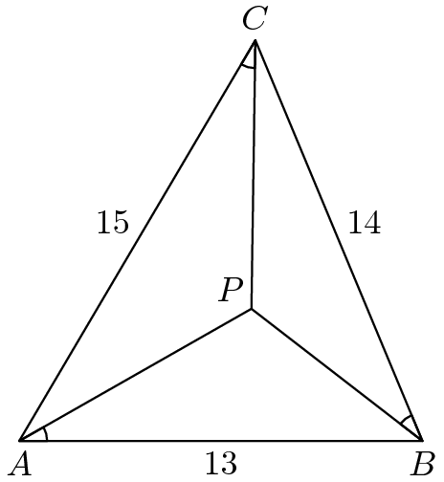

### Solution 1

Drop [perpendiculars](https://artofproblemsolving.com/wiki/index.php?title=Perpendicular) from $P$ to the three sides of $\triangle ABC$ and let them meet $\overline{AB}, \overline{BC},$ and $\overline{CA}$ at $D, E,$ and $F$ respectively.

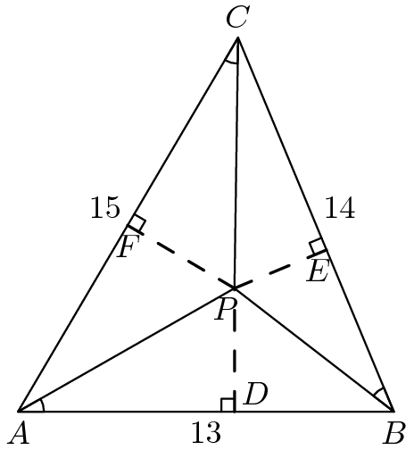

Let $BE = x, CF = y,$ and $AD = z$. We have that

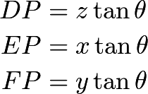

We can then use the tool of calculating area in two ways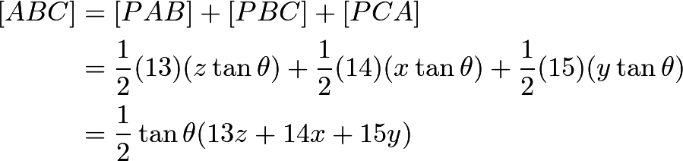

On the other hand,

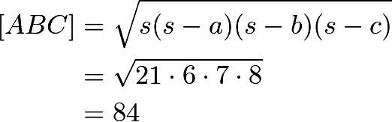

We still need $13z+14x+15y$ though. We have all these [right triangles](https://artofproblemsolving.com/wiki/index.php?title=Right_triangle) and we haven't even touched [Pythagoras](https://artofproblemsolving.com/wiki/index.php?title=Pythagorean_theorem). So we give it a shot: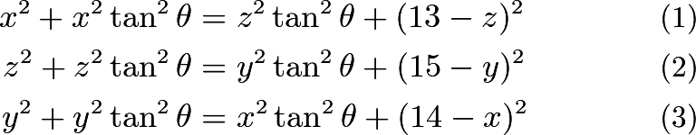

Adding $(1) + (2) + (3)$ gives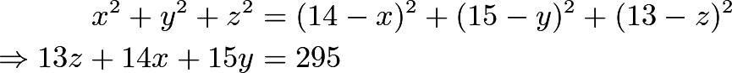

Recall that we found that

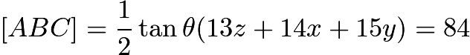.

Plugging in $13z+14x+15y=295$, we get 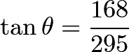, giving us $\boxed{463}$ for an answer.

### Solution 2

Let $AB=c$, $BC=a$, $AC=b$, $PA=x$, $PB=y$, and $PC=z$.

So by the [Law of Cosines](https://artofproblemsolving.com/wiki/index.php?title=Law_of_Cosines), we have:

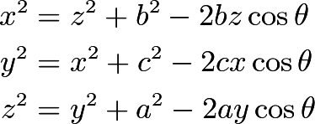

Adding these equations and rearranging, we have:\[a^2 + b^2 + c^2 = (2bz + 2cx + 2ay)\cos{\theta}\qquad(1)\]Now , by [Heron's formula](https://artofproblemsolving.com/wiki/index.php?title=Heron%27s_formula).

Now the area of a triangle, 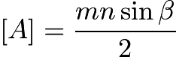, where $m$ and $n$ are sides on either side of an angle, $\beta$. So,

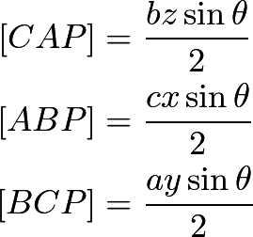

Adding these equations yields:

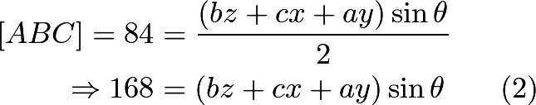

Dividing $(2)$ by $(1)$, we have: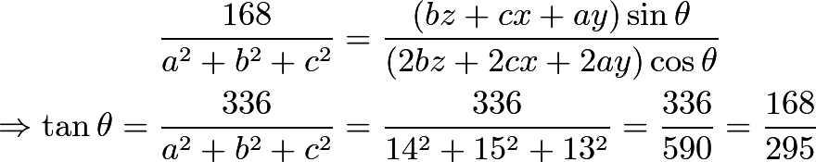Thus, $m + n = 168 + 295 = \boxed{463}$.

**Problem 15**

Consider the paper triangle whose vertices are $(0,0), (34,0),$ and $(16,24).$ The vertices of its midpoint triangle are the midpoints of its sides. A triangular pyramid is formed by folding the triangle along the sides of its midpoint triangle. What is the volume of this pyramid?